STRUCTURE
A Structure is a user defined data type that can store related information together. The variable within a structure are of different data types and each has a name that is used to select it from the structure. C arrays allow you to define type of variables that can hold several data items of the same kind but structure is another user defined data type available in C programming, which allows you to combine data items of different kinds.
Structures are used to represent a record, Suppose you want to keep track of your books in a library. You might want to track the following attributes about each book:
• Title
• Author
• Subject
• Book ID
Structure in c is a user-defined data type that enables us to store the collection of different data types. Each element of a structure is called a member.
The ,struct keyword is used to define the structure. Let's see the syntax to define the structure in c.
Structure Declaration:
It is declared using a keyword struct followed by the name of the structure. The variables of the structure are declared within the structure.
Example:
Struct struct-name
{
data_type var-name;
data_type var-name;
};

OR
struct structure_name
{
data_type member1;
data_type member2;
.
.
data_type memeberN;
};
Let's see the example to define a structure for an entity employee in c.
struct employee
{
int id;
char name[20];
float salary;
};
The following image shows the memory allocation of the structure employee that is defined in the above example.
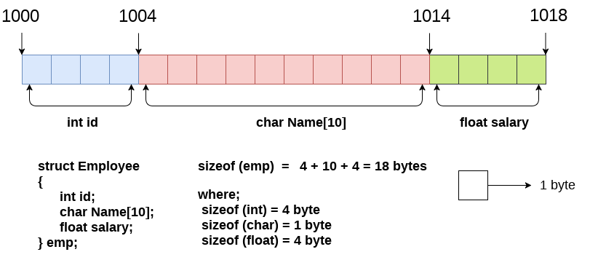
Here, struct is the keyword; employee is the name of the structure; id, name, and salary are the members or fields of the structure. Let's understand it by the diagram given below:
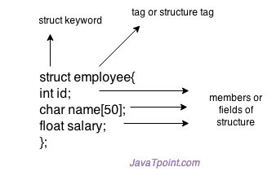
Declaring structure variable:
We can declare a variable for the structure so that we can access the member of the structure easily. There are two ways to declare structure variable:
- By struct keyword within main() function
- By declaring a variable at the time of defining the structure.
1st way:
Let's see the example to declare the structure variable by struct keyword. It should be declared within the main function.
struct employee
{ int id;
char name[50];
float salary;
};
Now write given code inside the main() function.
struct employee e1, e2;
The variables e1 and e2 can be used to access the values stored in the structure.

2nd way:
Let's see another way to declare variable at the time of defining the structure.
struct employee
{ int id;
char name[50];
float salary;
}e1,e2;
Accessing members of the structure:
There are two ways to access structure members:
- By . (member or dot operator)
- By -> (structure pointer operator)
Let's see the code to access the id member of p1 variable by. (member) operator
p1.id
C Structure example:
Let's see a simple example of structure in C language.
#include<stdio.h>
#include <string.h>
struct employee
{ int id;
char name[50];
}e1; //declaring e1 variable for structure
int main( )
{
//store first employee information
e1.id=101;
strcpy(e1.name, "Sonoo Jaiswal");//copying string into char array
//printing first employee information
printf( "employee 1 id : %d\n", e1.id);
printf( "employee 1 name : %s\n", e1.name);
return 0;
}
Output:
employee 1 id : 101
employee 1 name : Sonoo Jaiswal

Let's see another example of the structure in C language to store many employees information.
#include<stdio.h>
#include <string.h>
struct employee
{ int id;
char name[50];
float salary;
}e1,e2; //declaring e1 and e2 variables for structure
int main( )
{
//store first employee information
e1.id=101;
strcpy(e1.name, "Sonoo Jaiswal");//copying string into char array
e1.salary=56000;
//store second employee information
e2.id=102;
strcpy(e2.name, "James Bond");
e2.salary=126000;
//printing first employee information
printf( "employee 1 id : %d\n", e1.id);
printf( "employee 1 name : %s\n", e1.name);
printf( "employee 1 salary : %f\n", e1.salary);
//printing second employee information
printf( "employee 2 id : %d\n", e2.id);
printf( "employee 2 name : %s\n", e2.name);
printf( "employee 2 salary : %f\n", e2.salary);
return 0;
}
Output:
employee 1 id : 101
employee 1 name : Sonoo Jaiswal
employee 1 salary : 56000.000000
employee 2 id : 102
employee 2 name : James Bond
employee 2 salary : 126000.000000
typedef in C
The typedef is a keyword used in C programming to provide some meaningful names to the already existing variable in the C program. It behaves similarly as we define the alias for the commands. In short, we can say that this keyword is used to redefine the name of an already existing variable.
Syntax of typedef
- typedef <existing_name> <alias_name>
In the above syntax, 'existing_name' is the name of an already existing variable while 'alias name' is another name given to the existing variable.
For example, suppose we want to create a variable of type unsigned int, then it becomes a tedious task if we want to declare multiple variables of this type. To overcome the problem, we use a typedef keyword.
typedef unsigned int unit;
In the above statements, we have declared the unit variable of type unsigned int by using a typedef keyword.
Now, we can create the variables of type unsigned int by writing the following statement:
unit a, b;
instead of writing:
unsigned int a, b;
Till now, we have observed that the typedef keyword provides a nice shortcut by providing an alternative name for an already existing variable. This keyword is useful when we are dealing with the long data type especially, structure declarations.
Let's understand through a simple example.
#include <stdio.h>
int main()
{
typedef unsigned int unit;
unit i,j;
i=10;
j=20;
printf("Value of i is :%d",i);
printf("\nValue of j is :%d",j);
return 0;
}
Output
Value of i is :10
Value of j is :20
Using typedef with structures:
Consider the below structure declaration:
struct student
{
char name[20];
int age;
};
struct student s1;
In the above structure declaration, we have created the variable of student type by writing the following statement:
struct student s1;
The above statement shows the creation of a variable, i.e., s1, but the statement is quite big. To avoid such a big statement, we use the typedef keyword to create the variable of type student.

struct student
{
char name[20];
int age;
};
typedef struct student stud;
stud s1, s2;
In the above statement, we have declared the variable stud of type struct student. Now, we can use the stud variable in a program to create the variables of type struct student.
The above typedef can be written as:
typedef struct student
{
char name[20];
int age;
} stud;
stud s1,s2;
from the above declarations, we conclude that typedef keyword reduces the length of the code and complexity of data types. It also helps in understanding the program.
Let's see another example where we typedef the structure declaration.
#include <stdio.h>
typedef struct student
{
char name[20];
int age;
}stud;
int main()
{
stud s1;
printf("Enter the details of student s1: ");
printf("\nEnter the name of the student:");
scanf("%s",&s1.name);
printf("\nEnter the age of student:");
scanf("%d",&s1.age);
printf("\n Name of the student is : %s", s1.name);
printf("\n Age of the student is : %d", s1.age);
return 0;
}
Output
Enter the details of student s1:
Enter the name of the student: Peter
Enter the age of student: 28
Name of the student is : Peter
Age of the student is : 28

C Array of Structures:
Why use an array of structures?
Consider a case, where we need to store the data of 5 students. We can store it by using the structure as given below.
#include<stdio.h>
struct student
{
char name[20];
int id;
float marks;
};
void main()
{
struct student s1,s2,s3;
int dummy;
printf("Enter the name, id, and marks of student 1 ");
scanf("%s %d %f",s1.name,&s1.id,&s1.marks);
scanf("%c",&dummy);
printf("Enter the name, id, and marks of student 2 ");
scanf("%s %d %f",s2.name,&s2.id,&s2.marks);
scanf("%c",&dummy);
printf("Enter the name, id, and marks of student 3 ");
scanf("%s %d %f",s3.name,&s3.id,&s3.marks);
scanf("%c",&dummy);
printf("Printing the details....\n");
printf("%s %d %f\n",s1.name,s1.id,s1.marks);
printf("%s %d %f\n",s2.name,s2.id,s2.marks);
printf("%s %d %f\n",s3.name,s3.id,s3.marks);
}
Output
Enter the name, id, and marks of student 1 James 90 90
Enter the name, id, and marks of student 2 Adoms 90 90
Enter the name, id, and marks of student 3 Nick 90 90
Printing the details....
James 90 90.000000
Adoms 90 90.000000
Nick 90 90.000000
In the above program, we have stored data of 3 students in the structure. However, the complexity of the program will be increased if there are 20 students. In that case, we will have to declare 20 different structure variables and store them one by one. This will always be tough since we will have to declare a variable every time we add a student. Remembering the name of all the variables is also a very tricky task. However, c enables us to declare an array of structures by using which, we can avoid declaring the different structure variables; instead we can make a collection containing all the structures that store the information of different entities.
Array of Structures in C:
An array of structres in C can be defined as the collection of multiple structures variables where each variable contains information about different entities. The array of structures in C are used to store information about multiple entities of different data types. The array of structures is also known as the collection of structures.
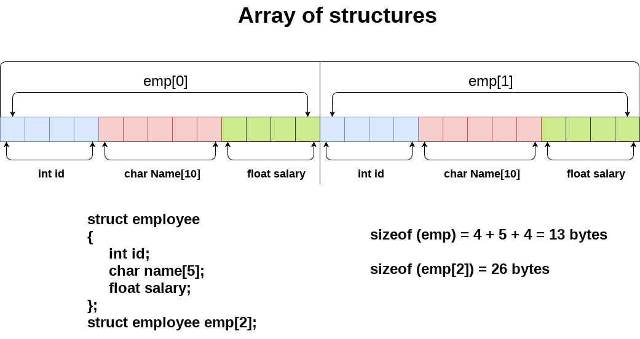
Let's see an example of an array of structures that stores information of 5 students and prints it.
#include<stdio.h>
#include <string.h>
struct student{
int rollno;
char name[10];
};
int main(){
int i;
struct student st[5];
printf("Enter Records of 5 students");
for(i=0;i<5;i++){
printf("\nEnter Rollno:");
scanf("%d",&st[i].rollno);
printf("\nEnter Name:");
scanf("%s",&st[i].name);
}
printf("\nStudent Information List:");
for(i=0;i<5;i++){
printf("\nRollno:%d, Name:%s",st[i].rollno,st[i].name);
}
return 0;
}
Output:
Enter Records of 5 students
Enter Rollno:1
Enter Name:Sonoo
Enter Rollno:2
Enter Name:Ratan
Enter Rollno:3
Enter Name:Vimal
Enter Rollno:4
Enter Name:James
Enter Rollno:5
Enter Name:Sarfraz

Student Information List:
Rollno:1, Name:Sonoo
Rollno:2, Name:Ratan
Rollno:3, Name:Vimal
Rollno:4, Name:James
Rollno:5, Name:Sarfraz
C Unions
Union is a collection of variables of different data types, in case of union information can only be stored In one field at any one time. A union is a special data type available in C that enables you to store different data types in the same memory location. You can define a union with many members, but only one member can contain a value at any given time. Unions provide an efficient way of using the same memory location for multi-purpose.
OR
The Union is a user-defined data type in C language that can contain elements of the different data types just like structure. But unlike structures, all the members in the C union are stored in the same memory location. Due to this, only one member can store data at the given instance.
Syntax of Union in C
The syntax of the union in C can be divided into three steps which are as follows:
C Union Declaration
In this part, we only declare the template of the union, i.e., we only declare the members’ names and data types along with the name of the union. No memory is allocated to the union in the declaration.
union union_name {
datatype member1;
datatype member2;
...
};
Keep in mind that we have to always end the union declaration with a semi-colon.
Different Ways to Define a Union Variable
We need to define a variable of the union type to start using union members. There are two methods using which we can define a union variable.
- With Union Declaration
- After Union Declaration
1. Defining Union Variable with Declaration
union union_name {
datatype member1;
datatype member2;
...
} var1, var2, ...;
2. Defining Union Variable after Declaration
union union_name var1, var2, var3...;
where union_name is the name of an already declared union.
Access Union Members
We can access the members of a union by using the ( . ) dot operator just like structures.
var1.member1;
where var1 is the union variable and member1 is the member of the union.
The above method of accessing the members of the union also works for the nested unions.
var1.member1.memberA;
Here,
- var1 is a union member.
- member1 is a member of the union.
- memberA is a member of member1.

Initialization of Union in C:

The initialization of a union is the initialization of its members by simply assigning the value to it.
var1.member1 = some_value;
One important thing to note here is that only one member can contain some value at a given instance of time.
Example of Union:
// C Program to demonstrate how to use union
#include <stdio.h>
// union template or declaration
union un {
int member1;
char member2;
float member3;
};
// driver code
int main()
{
// defining a union variable
union un var1;
// initializing the union member
var1.member1 = 15;

printf("The value stored in member1 = %d",
var1.member1);

return 0;
}
Output
The value stored in member1 = 15
Size of Union
The size of the union will always be equal to the size of the largest member of the array. All the less-sized elements can store the data in the same space without any overflow.
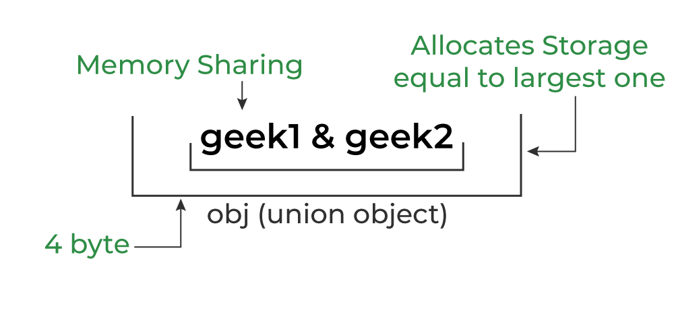

Difference between C Structure and C Union
The following table lists the key difference between the structure and union in C:
Structure | Union
The size of the structure is equal to or greater than the total size of all of its members. | The size of the union is the size of its largest member.
The structure can contain data in multiple members at the same time. | Only one member can contain data at the same time.
It is declared using the struct keyword. | It is declared using the union keyword.

FILE
A File is a collection of data stored on a secondary storage device like hard disk. File operation is to combine all the input data into a file and then to operate through the C program. Various operations like insertion, deletion, opening closing etc can be done upon a file. When the program is terminated, the entire data is lost in C programming. If you want to keep large volume of data, it is time consuming to enter the entire data. But, if file is created these information can be accessed using few commands.
There are large numbers of functions to handle file I/O in C language. In this tutorial, you will learn to handle standard I/O(High level file I/O functions) in C. High level file I/O functions can be categorized as:
1. Text file
2. Binary file
A file can be open in several modes for these operations. The various modes are:
r :open a text file for reading
w: truncate to zero length or create a text file for writing
a :append; open or create text file for writing at end-of-file rb open binary file for reading
wb: truncate to zero length or create a binary file for writing
ab :append; open or create binary file for writing at end-of-file r+ open text file for update (reading and writing)
w+ :truncate to zero length or create a text file for update
a+ :append; open or create text file for update

r+b or rb+ :open binary file for update (reading and writing)
w+b or wb+: truncate to zero length or create a binary file for update a+b or ab+ append; open or create binary file for update
fopen and freopen opens the file whose name is in the string pointed to by filename and associates a stream with it. Both return a pointer to the object controlling the stream, or if the open operation
fails a null pointer. The error and end-of-file(EOF) indicators are cleared, and if the open operation fails error is set. freopen differs from fopen in that the file pointed to by stream is closed first when already open and any close errors are ignored.
Q1. Write a program to open a file using fopen().
Ans:
#include<stdio.h>
void main()
{
fopen() file *fp;
fp=fopen(“student.DAT”, “r”);
if(fp==NULL)
{
printf(“The file could not be open”); exit(0);
}
Q2. Write a C program to read name and marks of n number of students from user and store them in a file. If the file previously exits, add the information of n students.
Ans:
#include <stdio.h>
int main()
{
char name[50];
int marks, i,n;
printf(“Enter number of students”);
scanf(“%d”, &n);
FILE *fptr;
fptr=(fopen(“C:\\student.txt”,”a”));
if (fptr==NULL)
{
printf("Error!");
exit(1);
}
for(i=0;i<n;++i)
{
printf("For student%d\nEnter name: ",i+1);
scanf("%s",name);
printf(“Enter marks”);
scanf(“%d”, &marks);
fprintf(fptr, “\nName: %s\nMarks=%d\n”, name, marks);
} fclose(fptr);
Return 0;
}
The fclose function causes the stream pointed to be flushed and the associated file to be closed. Any unwritten buffered data for the stream are delivered to the host environment to be written to the file; any unread buffered data are discarded. The stream is disassociated from the file. If the associated buffer was automatically allocated, it is deallocated. The function returns zero if the stream was successfully closed or EOF if any errors were detected.
Write a program to read data from file and close using fclose function.
Ans:
#include <stdio.h>
int main()
int n
FILE *fptr;
if ((fptr=fopen("C:\\program.txt","r"))==NULL)
{
printf("Error! opening file");
exit(1); // Program exits if file pointer returns NULL.
}
fscanf(fptr,"%d",&n);
printf("Value of n=%d",n);
fclose(fptr);
return 0;
}

